**Help us make our website work for everyone!**

We are making a new website.

We want people with disability to test it to make sure it works well. We want to make sure our website:

* is easy to access and use
* includes everyone.

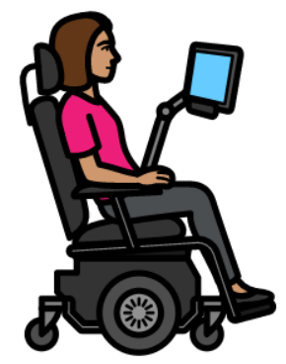We want to hear from people who

* Have different access needs
* Use screen readers
* Use Easy English.

You can test the website on your own device. It could be a computer or phone.





We will give you simple instructions on what to test. You do not need to be good with technology.



The test will take about 2 hours. It will be in September 2025.

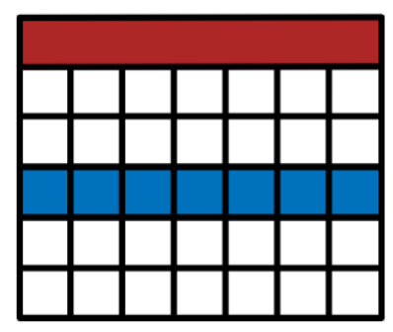We will give you a link to the test. You will have 1 week to do it and share your feedback.



We will give you a gift for your time.



Do you want to take part? Please fill out the short form on our website: <https://purpleorange.org.au/news-resources/help-us-make-our-website-work-everyone>

Please email the completed form to [media@juliafarr.org.au](mailto:media@juliafarr.org.au) by Thursday 21 August 2025.