**Form to show your interest in testing out our new website**

We want people with disability to test our new website.

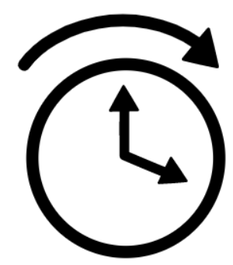

The test will be in September. It will take about 2 hours to complete.

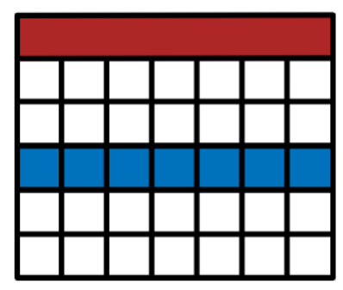

You will have 1 week to do the test in your own time. You can do it on your own device (desktop computer, laptop, mobile phone, etc.).

We will give you simple instructions to guide the test.

We will give you a gift for your time.

Do you want to take part?

Please fill out the form below.

Note: This form is just to say that you are interested. We will let you know if you are chosen to take part or not.

**Your details**

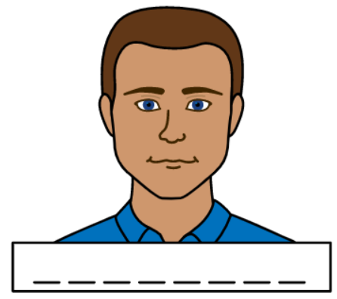

What is your first name? ____________________________________________



What is your last name? ____________________________________________





What is your email?

____________________________________________

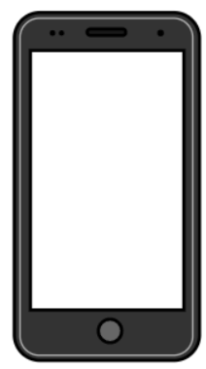

What is your phone number?

____________________________________________

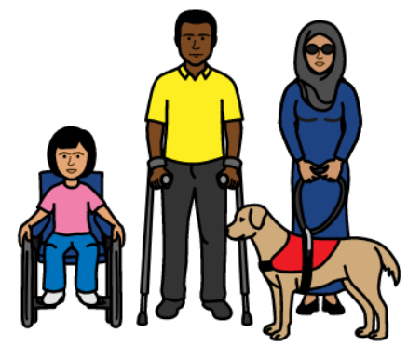Do you have a disability?

Yes

No

I do not want to say

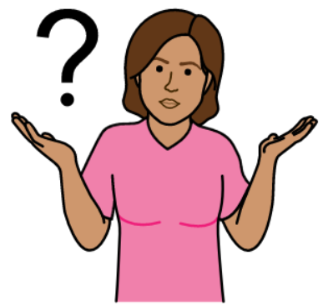Why do you want to take part in testing our website?

________________________________________________________________________________________________________________________________________________________________________________



Do you use any of these things when using websites?  
(You can choose as many as you like)

Screen reader

Easy English

Screen magnifier

Keyboard navigation

Voice control

Other_____________________________________

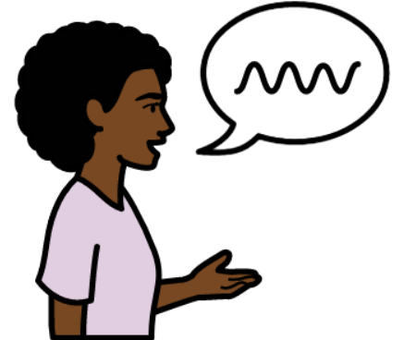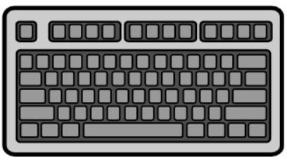

Which screen reader software do you usually use?

JAWS for Windows

NVDA for Windows

Narrator for Windows

VoiceOver for Apple devices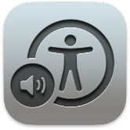

Talkback for Android devices

SuperNova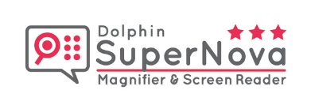

System Access

Thunder

ChromeVox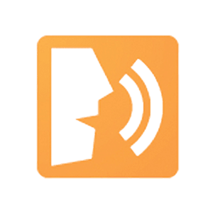

I do not use a screen reader

Other_______________________________



What device(s) would you be using to test our website?

(You can choose as many as you like)

Desktop computer

Laptop

Mobile phone

Tablet

Other________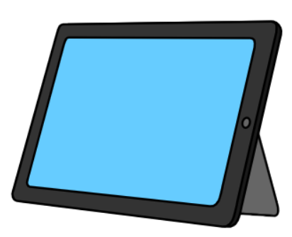_____________________________

We will email the website link and instructions. Do you have any communication or access needs you would like us to know about?

Yes

No

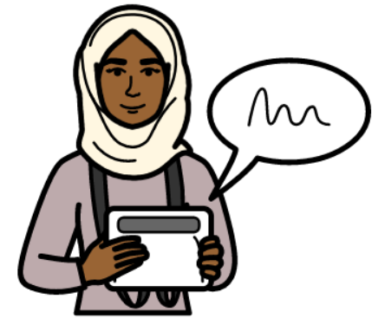If yes, please tell us your communication or access needs.

____________________________________________________________________________________________________________________________________

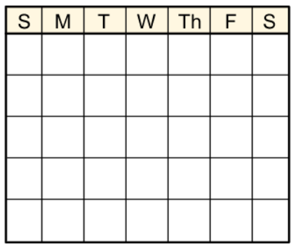Are you able to do the test in September? Keep in mind, this time could change.

Yes

No

I am not sure