Information kit for stakeholders, peak bodies and advocates
Contents
Information about the NDIS Commission 4
Information about complaints 6
How you can help 7
More detailed information about the NDIS Commission 9
Publications (digital and printed) 16
Editorial 18
Social media posts 20
Web badge and description 23
More information 24

About this kit
This kit provides information to key stakeholders about the new Commonwealth government agency called the NDIS Quality and Safeguards Commission (NDIS Commission).
The NDIS Commission started in New South Wales and South Australia on 1 July 2018.
By 1 July 2020, the NDIS Commission will be available in all states and territories.
This kit has been developed to explain key aspects of the NDIS Commission, and provide you with materials and messages to share with your staff, disability providers and workers, NDIS participants, and families and carers.

Who is this kit for?
This kit is for Commonwealth, New South Wales and South Australian stakeholders, provider peak bodies and advocates.
Tailored information kits are also being distributed to:
- NDIS participants and self-managed participants, and their families and carers, in New South Wales and South Australia.
- Local Area Coordinators, planners and Early Childhood Early Intervention partners in New South Wales and South Australia
- Commonwealth, New South Wales and South Australian government departments, agencies and regulatory bodies, MPs and Senators, and Ministers.

Information about the NDIS Commission
The NDIS Quality and Safeguards Commission (NDIS Commission) is a new independent Commonwealth agency that will help improve the quality and safety of NDIS supports and services.
The NDIS Commission is now available in New South Wales and South Australia.
By 1 July 2020, the NDIS Commission will be available in all states and territories.
The NDIS Commission, when fully rolled out, will promote quality and safe services for all NDIS participants no matter where they live.

What does the NDIS Commission mean for NDIS participants?
A strong, nationally consistent quality and safeguards system is now in place in New South Wales and South Australia.
The NDIS Commission can help NDIS participants and their families and carers, resolve concerns or complaints about NDIS supports and services.
All disability providers and workers in New South Wales and South Australia must follow a new NDIS Code of Conduct. The Code sets out the standards of quality and safety required for NDIS services and supports. We have the power to take action if a provider or worker does not meet the new NDIS Code of Conduct.
An improved worker-screening system is being developed and will soon be in place in New South Wales and South Australia. Until the new system is in place, existing worker screening and police check requirements in your state will continue.
Over time, we will identify improvements to the NDIS that will benefit everyone.

What does the NDIS Commission mean for providers and workers?
All providers (registered and unregistered) and workers in New South Wales and South Australia need to:
- provide participants with safe, quality supports and services
- uphold participants’ right to be free from harm
- follow the new NDIS Code of Conduct.
In addition, we require all NDIS registered providers in New South Wales and South Australia to:
- have a complaints system in place
- meet the new NDIS Practice Standards
- report certain types of incidents to the NDIS Commission, including incidents or allegations of abuse and neglect
- report their use of restrictive practices and behaviour support plans, with the aim of reducing and eliminating such practices.
We will support and educate providers and workers to ensure they meet their responsibilities.

When is the NDIS Commission available in other states and territories?
The NDIS Commission starts on:
- 1 July 2018 in New South Wales and South Australia
- 1 July 2019 in the Australian Capital Territory, Northern Territory, Queensland, Tasmania and Victoria
- 1 July 2020 in Western Australia.
NDIS participants are covered under their state or territory’s existing quality and safeguards systems until the NDIS Commission is available.

Does the NDIS Commission replace the NDIA?
No. The NDIS Commission does not replace the National Disability Insurance Agency (NDIA).
The NDIA will continue to:
- deliver the NDIS
- provide individualised plans and support people with disability
- coordinate service bookings, payments and access to plans for providers
- handle complaints about the NDIA itself, eligibility funding and participant plans.
The NDIA will share news and information with participants about the NDIS Commission through the myplace participant portal, NDIS newsletters and NDIS participant information sessions.

Information about complaints

If a participant feels unsafe or unhappy with their NDIS services
Participants have the right to be safe and receive quality services from the providers and workers they choose to support them under the NDIS.
If a participant feels unsafe or unhappy with their NDIS services, they have the right to complain. Families, carers, advocates, workers or someone else can also complain on behalf of the participant.
If a participant has a concern, we encourage them to talk to their provider first. They can ask someone they trust or an independent advocate to help them.
If the participant doesn’t want to talk to the provider or if they are unhappy with the provider’s response, they can contact the NDIS Commission. Our contact details are on page 23.
We will help try to resolve any concerns.
We will work with participants, and with providers and workers, to improve the quality and safety of NDIS supports – for them and other participants.
If we can’t help – for example, if the NDIS participant doesn’t live in New South Wales or South Australia – we will connect them with the right organisation.
Our brochure How to make a complaint has more information.

If a participant is unhappy with the NDIA
The NDIS Commission does not handle complaints about the NDIA. If a participant is unhappy with the NDIA and wants to make a complaint, they need to contact the NDIA:
- Phone 1800 800 110
- Visit an NDIA office
- Complete a complaints form and:
  - email it to feedback@ndis.gov.au
  - post it to National Disability Insurance Agency, GPO Box 700, Canberra ACT 2601
  - drop the form off at an NDIA office.
For the complaints form and a list of NDIA offices, visit www.ndis.gov.au
If the participant is not satisfied with the NDIA’s response to their complaint, they can contact the Commonwealth Ombudsman. Phone 1300 362 072.

How you can help
As a peak body, advocate or key stakeholder, you can inform NDIS participants, families and carers, providers and their NDIS workers about the role of the NDIS Commission, and help them engage with us.

Supporting NDIS participants, families and carers
- Read the information in this kit.
- Ensure NDIS participants, families and carers understand that it is OK to complain. Raising a concern can help them and other people with disability.
- During conversations with a NDIS participant, family member or carer, ask them about any concerns they may have about the quality or safety of NDIS supports and services.
- Provide NDIS participants, families and carers in New South Wales and South Australia with information about the NDIS Commission. Ensure they understand the role and responsibilities of the NDIS Commission, what it does, and how it can help.
- Support NDIS participants, families and carers to raise any concerns with the provider or NDIS Commission.
- Provide NDIS participants, families and carers with the NDIS Commission publications Overview of the NDIS Quality and Safeguards Commission and How to make a complaint. See page 15.
- Hold information sessions or workshops with NDIS participants, families and carers about how they can raise and resolve concerns about NDIS supports and services. Provide information about the NDIS Commission, and provide the publications mentioned above.
- Include an article about the NDIS Commission in your organisation’s newsletter. See page 17 for a suggested article.
- Visit the NDIS Commission website www.ndiscommission.gov.au to find out more.

Supporting providers
- Read the information in this kit.
- Ensure NDIS providers understand what the NDIS Commission means for them and their staff, including the new Code of Conduct.
- Ensure providers understand that the NDIS Commission is currently operating only in New South Wales and South Australia. Providers in other states and territories are not affected at this stage, and their current state or territory quality and safeguards systems continue to apply.
- Ensure registered NDIS providers in New South Wales and South Australia understand that their registration will automatically transfer from the NDIA to the NDIS Commission, and that they don’t need to do anything until their registration is due for renewal.
- Encourage unregistered providers in New South Wales and South Australia to find out whether or not they need to register with the NDIS Commission.
- Encourage NDIS providers to tell their staff about the NDIS Commission, the role and responsibilities of the NDIS Commission, what it does, and what it means for workers.
- Encourage providers to ask NDIS participants, families and carers for feedback about NDIS supports and services and encourage providers to proactively resolve any concerns.
- Share copies of NDIS Commission publications with providers and workers in New South Wales and South Australia. See page 15.
- Encourage providers in New South Wales and South Australia to register for NDIS Commission provider information sessions. The details are on the NDIS Commission website www.ndiscommission.gov.au
- Include an article about the NDIS Commission in your organisation’s newsletter. See page 17 for a suggested article.
- Visit the NDIS Commission website www.ndiscommission.gov.au to find out more.

More detailed information about the NDIS Commission

How to use
We encourage you to use these messages when you are communicating with NDIS participants, families and carers from 1 July 2018. Your staff will also benefit from this information.

Information for all audiences
- The NDIS Quality and Safeguards Commission is a new independent Commonwealth agency established to improve the quality and safety of NDIS supports and services.
- The NDIS Commission will register and regulate NDIS providers, provide national consistency, promote safety and quality and response to concerns and complaints about NDIS supports and services.
- The NDIS Commission started in New South Wales and South Australia on 1 July 2018.
- In New South Wales and South Australia, this means:
  - a new NDIS Code of Conduct now applies to providers and workers
  - registered providers need to meet new NDIS Practice Standards, report certain types of incidents, report restrictive practices, and have a strong complaints system in place
  - participants can contact the NDIS Commission to raise a concern or make a complaint.
- The NDIS Commission will start in the Australian Capital Territory, Northern Territory, Queensland, Tasmania and Victoria on 1 July 2019; and in Western Australia on 1 July 2020.
- Until the NDIS Commission starts operating in these areas, current state or territory requirements for quality and safeguards continue to apply.
- The NDIS Commission, when fully rolled out, will promote quality and safe services and supports for all NDIS participants no matter where they live.
- For more information, visit the NDIS Commission website www.ndiscommission.gov.au

The NDIS Commission’s responsibilities
The NDIS Commission:
- responds to concerns, complaints and reportable incidents, including abuse and neglect of NDIS participants
- promotes the NDIS principles of choice and control, and works to empower participants to exercise their rights to access quality services as informed, protected consumers
- requires NDIS providers to uphold participants' rights to be free from harm
- registers and regulates NDIS providers, and oversees the new NDIS Code of Conduct and Practice Standards
- provides guidance and best practice information to NDIS providers on how to comply with their registration responsibilities, including how to provide culturally responsive and appropriate disability supports
- monitors compliance against the NDIS Code of Conduct and Practice Standards, including undertaking investigations and taking enforcement action
- monitors the use of restrictive practices within the NDIS, with the aim of reducing and eliminating such practices
- leads collaboration with states and territories to design and implement nationally consistent NDIS worker screening
- focuses on education, capacity building and development for people with disability, NDIS providers and workers
- facilitates information sharing with the National Disability Insurance Agency (NDIA), state and territory authorities, and other Commonwealth regulatory bodies.

Information for participants in NSW and SA
- You have the right to be safe and to receive quality services from the providers and workers you choose to support you under the NDIS.
- A strong and consistent quality and safeguards system is now in place in New South Wales and South Australia.
- The NDIS Commission can help you resolve concerns or complaints about NDIS supports and services.
- All disability providers and workers in your state must follow a new NDIS Code of Conduct. The Code sets out the standards of quality and safety required for NDIS services and supports.
- The NDIS Commission has the power to take action if a provider or worker does not meet the new NDIS Code of Conduct.
- A new national worker screening system is being developed and will soon be in place in your state. Worker screening is a way to check that people who wish to work with NDIS participants can be trusted to work with people with disability. Until the new system is in place, existing worker screening and police check requirements in your state will continue.
- The NDIS Commission expects all NDIS providers and workers in New South Wales and South Australia to:
  - provide you with safe, quality supports and services
  - uphold your right to be free from harm
  - follow the new NDIS Code of Conduct.
- In addition, the NDIS Commission requires all registered providers in New South Wales and South Australia to:
  - have a complaints system in place, and manage the complaints they receive
  - meet the new NDIS Practice Standards
  - report certain types of incidents to the NDIS Commission, including incidents or allegations of abuse and neglect
  - report the use of restrictive practices and behaviour support plans, with the aim of reducing and eliminating restrictive practices.

Information for participants about making a complaint
- If you feel unsafe or unhappy with your NDIS services, you have the right to complain.
- It’s OK to complain. Speaking up can help improve services for you and others.
- If you have a concern, try talking to your provider first. You can ask someone you trust, or an independent advocate, to help you.
- If you don’t want to talk to your provider, or you are unhappy with their response, contact the NDIS Commission.
- The NDIS Commission will help try to resolve your concerns.
- The NDIS Commission will work with you, providers and workers, to improve the quality and safety of NDIS supports – for you and other participants.
- If you’re not sure who to contact, the NDIS Commission will help you contact the right organisation.
- To make a complaint or to find out more about your options, call the NDIS Commission on 1800 035 544 or visit the website www.ndiscommission.gov.au

Information for providers in NSW and SA

What are the changes?
- From 1 July 2018, all providers and workers in New South Wales and South Australia who are supporting NDIS participants will be expected to:
  - deliver safe, quality supports and services to NDIS participants
  - uphold NDIS participants’ right to be free from harm
  - follow the new NDIS Code of Conduct.
- In addition, registered providers in New South Wales and South Australia must:
  - have a complaints system in place
  - meet the new NDIS Practice Standards
  - report certain types of incidents to the NDIS Commission, including incidents or allegations of abuse and neglect
  - report the use of restrictive practices and behaviour support plans, with the aim of reducing and eliminating such practices.
- A new national worker screening system is being developed and will soon be in place in New South Wales and South Australia. Until the new system is in place, existing worker screening and police check requirements in each state and territory will continue.

Benefits
- The expectations for how supports and services are to be delivered to NDIS participants will be clear to both providers and people with disability.
- The NDIS Commission will build the capability of NDIS participants and providers to uphold the rights of people with disability, and realise the benefits of the NDIS.
- These arrangements will support NDIS participants to be informed users of NDIS supports and services, and to live free from abuse, neglect, violence and exploitation.
- It will be easy to make a complaint about an NDIS support or service, and a nationally consistent approach to working with NDIS providers and people with disability to resolve complaints.
- The NDIS Commission will support providers to meet these new responsibilities, and deliver quality NDIS supports and services to NDIS participants.
- The new, nationally consistent approach to quality and safeguards will progressively replace existing state and territory arrangements. From July 2020 there will be a single system right across Australia.
- A single registration and regulatory system will reduce duplication and inconsistency, and help providers meet the required standards.
- There will be a responsive and proportionate approach to regulation that reflects the scale and scope of the NDIS providers.
- Nationally consistent NDIS worker screening, together with the single registration and regulatory system, will make it easier for providers to operate in multiple jurisdictions.
- The NDIS Commission will educate providers about behaviour support strategies that reduce and eliminate restrictive practices.
- The NDIS Commission will share information that supports capacity building.

Registration
- New South Wales and South Australian providers’ existing registration details have automatically transferred across from the NDIA to the NDIS Commission. Providers don’t need to do anything until their registration is due for renewal.
- Providers in New South Wales and South Australia must register with the NDIS Commission if they want to claim payments from the NDIA, or if they deliver specialist disability accommodation, use restrictive practices, or develop behaviour support plans.
- Providers in New South Wales and South Australia applying for registration with the NDIS Commission must demonstrate they meet the new NDIS Practice Standards.
- The NDIA will continue to manage registration in other states and territories, until the NDIS Commission is available in that location.

NDIS Practice Standards
- The NDIS Practice Standards create an important benchmark for NDIS providers to assess their performance, and to demonstrate how they provide high quality and safe supports and services to NDIS participants.
- NDIS providers must comply with the NDIS Practice Standards relevant to the supports and services they deliver, to become and remain registered as an NDIS provider with the NDIS Commission.
- Some parts of the NDIS Practice Standards apply to all registered NDIS providers.
- Other parts apply only to providers delivering more complex supports such as behaviour support, early childhood supports, specialist support coordination, and specialist disability accommodation.
- The NDIS Practice Standards consists of a series of high-level, participant-focused outcomes, each with a number of quality indicators.
- Providers will self-assess against the relevant NDIS Practice Standards.
- An independent auditor will use the quality indicators to assess a provider’s compliance with the NDIS Practice Standards.

Publications (digital and printed)

How to use
Please share these publications with NDIS participants, families and carers.
Publications can be found on the NDIS Commission website at www.ndiscommission.gov.au

Publications for people with disability, families and carers
Thumbnail | Description
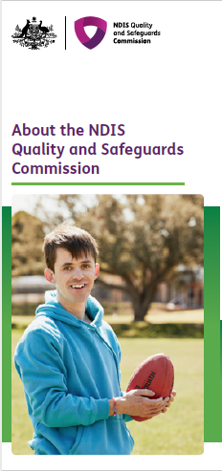 | Overview of the NDIS Quality and Safeguards Commission  This fact sheet explains what the NDIS Commission does, when we are available in other states and territories, and what it means for NDIS participants and providers.
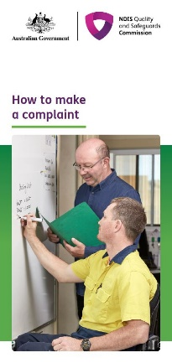 | How to make a complaint  This is a brochure for NDIS participants and their families, carers, advocates and workers. It explains how people can make a complaint to the NDIS Commission.

Publications for providers and workers
Thumbnail | Description
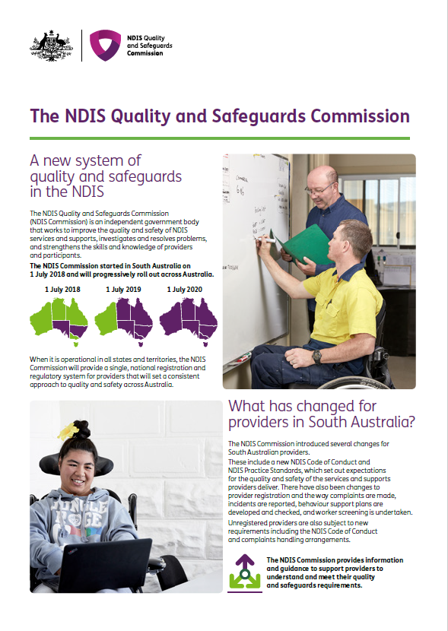 | What’s changed for South Australian providers?  This fact sheet explains what is changing for South Australian providers from 1 July 2018.
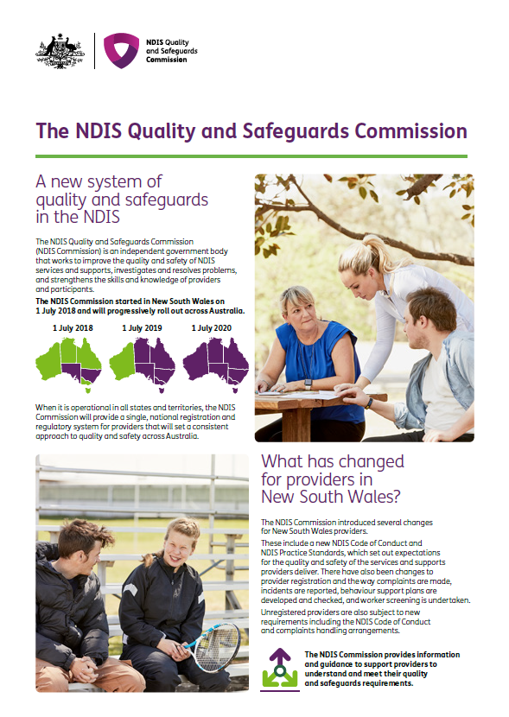 | What’s changed for New South Wales providers?  This fact sheet explains what is changing for New South Wales providers from 1 July 2018.
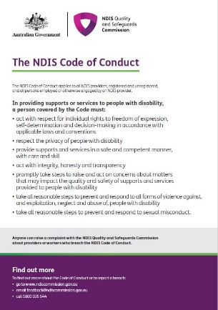 | The NDIS Code of Conduct  This fact sheet explains the new NDIS Code of Conduct, which now applies to providers and workers in South Australia and New South Wales.
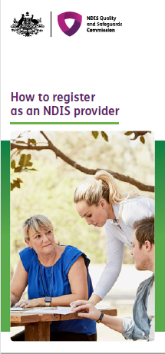 | How to register with the NDIS Commission  This fact sheet explains which providers need to register with the NDIS Commission, the registration process, and how providers are assessed against the NDIS Practice Standards.
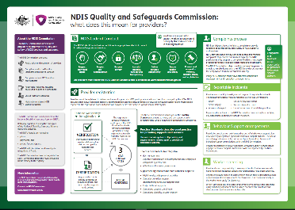 | Provider obligations – NDIS Commission  Poster outlining provider obligations under the NDIS Commission.

Editorial

How to use
From 1 July 2018, please share this editorial (through internal communications, external newsletters and other communications) with your staff, NDIS participants, providers, disability workers, families and carers.

Strong, consistent NDIS quality and safeguards are now in place in New South Wales and South Australia
The National Disability Insurance Scheme (NDIS) is fundamentally changing the way people with disability are supported in their everyday lives.
The changes needed to implement the NDIS are significant. That’s why it is important to have a strong, nationally consistent quality and safeguards system.
An independent Commonwealth government agency has been established – the NDIS Quality and Safeguards Commission, led by NDIS Commissioner Mr Graeme Head – to promote safe and quality services for NDIS participants.
The NDIS Commission started in New South Wales and South Australia on 1 July 2018.
In New South Wales and South Australia, this means:
- a new NDIS Code of Conduct now applies to NDIS providers and workers
- registered providers need to meet new NDIS Practice Standards, report certain types of incidents, report restrictive practices, and have a strong complaints system in place
- participants can contact the NDIS Commission to raise a concern or make a complaint.
Mr Head says NDIS participants have the right to be safe and to receive quality services from the providers and workers they choose to support them under the NDIS.
“If that’s not happening, participants have the right to complain. And we encourage it, because speaking up helps improve the NDIS for everyone,” he said.
Mr Head wrote to registered providers in New South Wales and South Australia in May 2018 to explain the changes and what it means for them.
“Providers’ existing registration details have automatically transferred across from the NDIA to the Commission. They don’t need to do anything until we contact them about renewing their registration.
“Unregistered providers can choose to register with the NDIS Commission. There certainly are benefits in doing so. However, there is no rush. They can contact us to register when they are ready.”
The NDIS Commission will start in the Australian Capital Territory, Northern Territory, Queensland, Tasmania and Victoria on 1 July 2019; and in Western Australia on 1 July 2020.
Until the NDIS Commission starts operating in these areas, current state or territory requirements for quality and safeguards continue to apply.
“The NDIS Commission, when fully rolled out, will promote quality and safe services for all participants no matter where they live.”
For more information, visit the NDIS Commission website www.ndiscommission.gov.au

Social media posts

How to use
Please share these posts with your social media networks from 1 July 2018.
Note: The NDIS Commission will establish a social media presence in late 2018. Until then, we encourage stakeholders and partners to spread the word through their own social media channels.

Facebook
Audience | Facebook text
All | The NDIS is a big change. It’s important to have a strong, consistent quality and safeguards system in place.  The NDIS Quality and Safeguards Commission has been established to promote safe and quality services for NDIS participants.  The NDIS Commission is available NOW in New South Wales and South Australia. It will be available across Australia by 1 July 2020.  In NSW and SA, it means a new Code of Conduct applies to providers and workers, registered providers need to meet NDIS Practice Standards, report certain types of incidents, report restrictive practices, and have a strong complaints system in place, and participants can contact the NDIS Commission to make a complaint.  Find out more at www.ndiscommission.gov.au  #NDIS #NDISCommission
All | The new, independent NDIS Quality and Safeguards Commission began operating in New South Wales and South Australia on 1 July 2018. It will improve the quality and safety of NDIS services, investigate and resolve problems, and strengthen the skills and knowledge of providers and participants across Australia.  Find out more at www.ndiscommission.gov.au  #NDIS #NDISCommission
All | The new NDIS Quality and Safeguards Commission is now operating in New South Wales and South Australia. Everything you need to know about the NDIS Commission, including the changes for NDIS participants and providers, is on the website.  Find out more at www.ndiscommission.gov.au  #NDIS #NDISCommission
Participants | If you feel unsafe or unhappy with your NDIS services, you have the right to complain.  NDIS participants in New South Wales and South Australia can now contact the new, independent NDIS Quality and Safeguards Commission to raise a concern or make a complaint.  Find out more at www.ndiscommission.gov.au  #NDIS #NDISCommission
Providers | Are you a registered NDIS provider in New South Wales or South Australia?  The new, independent NDIS Quality and Safeguards Commission began operating in New South Wales and South Australia on 1 July 2018, and there are some changes you need to know about.  Find out more at www.ndiscommission.gov.au  #NDIS #NDISCommission

Twitter
- #NDIS is a big change. The #NDISCommission promotes safe, quality services for NDIS participants. Now in NSW & SA www.ndiscommission.gov.au
- A new, independent #NDISCommission will promote safe, quality services for #NDIS participants now in NSW & SA www.ndiscommission.gov.au
- The #NDISCommission is available NOW in NSW & SA, with changes for #NDIS participants & providers. www.ndiscommission.gov.au
- NDIS participants who feel unsafe or unhappy with #NDIS services have the right to complain. NSW & SA now contact #NDISCommission. www.ndiscommission.gov.au
- Are you a registered NSW or SA #NDIS provider? The independent #NDISCommission started in these states on 1 July. Check out changes www.ndiscommission.gov.au

Web badge and description

How to use
Please publish the web badge, description and URL to your website(s) from 1 July 2018.

Web badge graphic
The graphic is available separately as an attachment to this information kit. 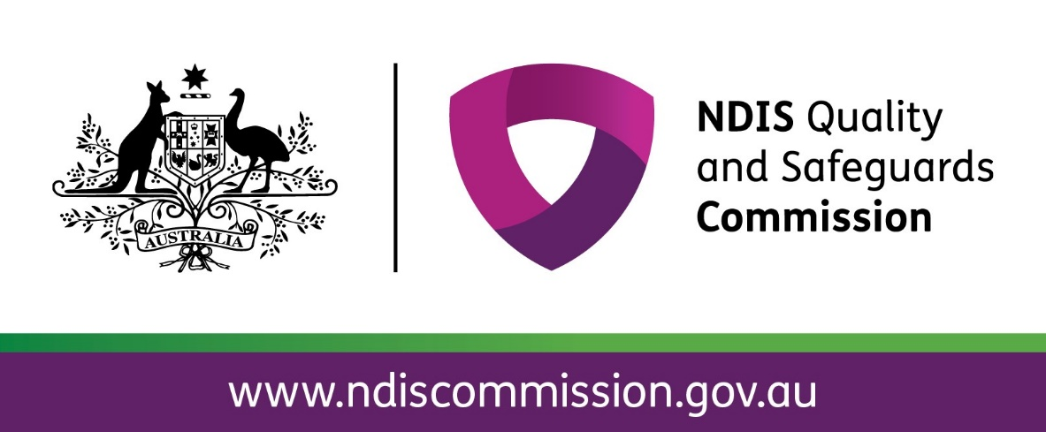

Description
The independent NDIS Quality and Safeguards Commission works to improve the quality and safety of NDIS supports and services. It is now available in New South Wales and South Australia. The website has information about the NDIS Commission for NDIS participants, families and carers, providers and workers.

URL
www.ndiscommission.gov.au

More information

Contact the NDIS Commission

Call us
Phone the NDIS Commission on 1800 035 544.
We are available Monday to Friday, 9 am to 5 pm Australian Eastern Standard Time.
It is free to phone from a landline telephone. Calling from a mobile phone may incur a charge.
National Relay Service
Visit www.relayservice.gov.au then
Voice: 1800 555 660
TTY: 1800 555 630
Translating and Interpreting Service
Phone 131 450

Email us
feedback@ndiscommission.gov.au

Visit the NDIS Commission website
Visit our website www.ndiscommission.gov.au for information about:
- how to raise a concern or make a complaint
- start dates for the NDIS Commission
- information about NDIS Commissioner Mr Graeme Head and staff
- the NDIS Code of Conduct for all providers and workers
- guidance for providers about registration, the NDIS Practice Standards, reporting and managing incidents, reporting restrictive practices and behaviour support plans
- legislation, rules and policies.

How to make a complaint
Call us on 1800 035 544.
You can submit a complaint online at www.ndicommission.gov.au
You can send an email to complaints@ndiscommission.gov.au

Legislation, rules and policies

Legislation
National Disability Insurance Scheme Amendment (Quality and Safeguards Commission and Other Measures) Act 2017

NDIS Rules
- Summary of the NDIS Rules: www.ndiscommission.gov.au/document/551
- Code of Conduct
- Registration and Practice Standards
- Quality Indicators
- Restrictive practices and behaviour support
- Specialist disability accommodation conditions
- Specialist disability accommodation – participating jurisdictions
- Transitional rules
- Incident management and reportable incidents
- Complaints management and resolution
- Provider definition
- Protection and disclosure of information

NDIS Quality and Safeguards Framework
The NDIS Quality and Safeguarding Framework promotes high-quality supports and safe environments for all NDIS participants.

NDIS Practice Standards
The NDIS Practice Standards set out the requirements providers must comply with to become and remain registered as an NDIS provider with the NDIS Commission.

NDIS Code of Conduct
The NDIS Code of Conduct applies to all NDIS providers (registered and unregistered) and their workers in New South Wales and South Australia from 1 July 2018.

