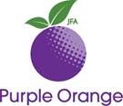
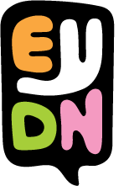
Co-design Application Form

This document has some hard words.
We will write what the hard words mean.
This is a form to apply to help EYDN with co-design.
The role is voluntary (not-paid).

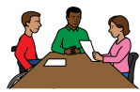
Co-design
Co-design is when people living with disability help EYDN by giving advice.
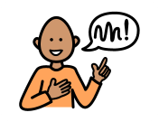
Advice
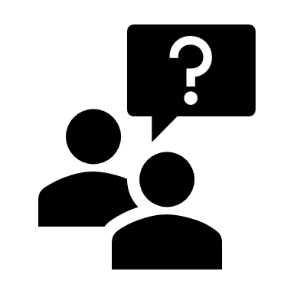
Advice is when you tell someone what you think.
You can ask for help to read this document.
Like from a:
- Family member
- Friend
- Support worker

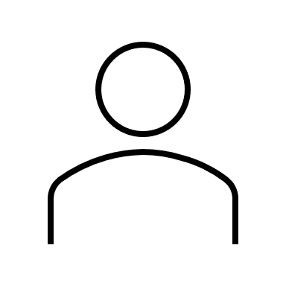
Questions

What is your name?
_________________________________________________
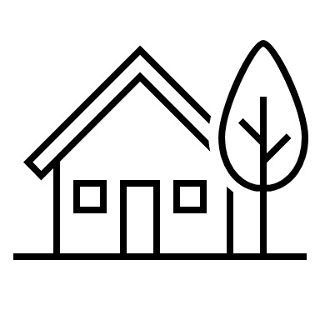
What is your address?

_________________________________________________
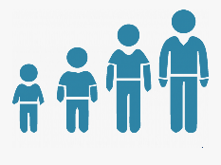
How old are you?

_________________________________________________
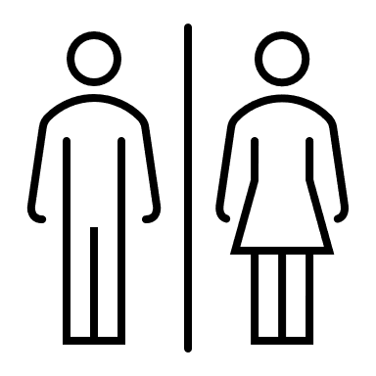
Are you male or female?
_________________________________________________

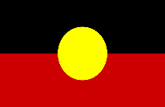
Are you Aboriginal or Torres-Strait Islander?

_________________________________________________
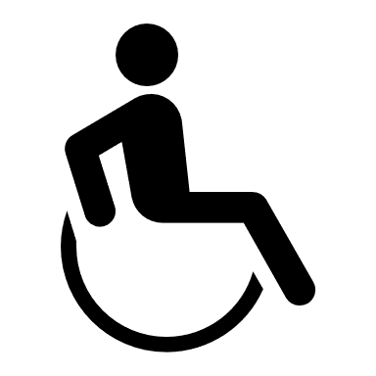
Do you have a disability?
_________________________________________________

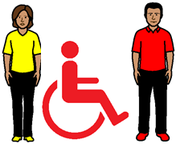
Do you have an intellectual disability?
________________________________________________

Do you have a physical disability?
________________________________________________

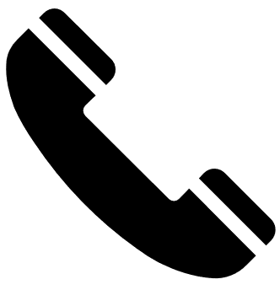
How can we contact you?

Phone ___________________________________________

Email ____________________________________________

Have you had help to fill in this application?
(please tick)
o No, I wrote this application myself.
o Yes, someone helped me with this application.
The name of the person that helped me with this application is_______________________________________________

It is ok if you have had help to write this application.

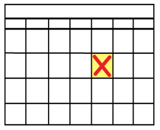
Signature: ________________________________________

Date:_____/______/______/

Interviews
We might contact you for more information.
We will ask you things like:
- Do you need help at the meetings? Eg. from a support worker or a translator?
- What is your availability?
- Have you worked with Purple Orange before?

