Peer Mentor Job Application Form

Questions
What is your name?

_________________________________________________

What is your address?

_________________________________________________

How can we contact you?

Phone ___________________________________________

Email ____________________________________________

Why do you want to be a peer mentor?
_________________________________________________
_________________________________________________
_________________________________________________
What are you good at?
_________________________________________________
_________________________________________________
_________________________________________________

What education or training have you had?
_________________________________________________
_________________________________________________
_________________________________________________

What other jobs have you had?
_________________________________________________
_________________________________________________
_________________________________________________

Who can tell us about you and your work? These people are called references. Write 2 people.
Name____________________________________________
Phone ___________________________________________
Email ____________________________________________
Name____________________________________________
Phone ___________________________________________
Email ____________________________________________
Have you had help to fill in this application?
(please tick)
o No, I wrote this application myself.
o Yes, someone helped me with this application.
The name of the person that helped me with this application is_______________________________________________

It is ok if you have had help to write this application.

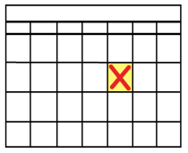
Signature: ________________________________________

Date:_____/______/______/

Interviews
We might contact you for an interview.

In the interview we will ask you things like
- Why do you want to work with us?
- What are you good at?

You can bring a support person with you to the interview if you want.

