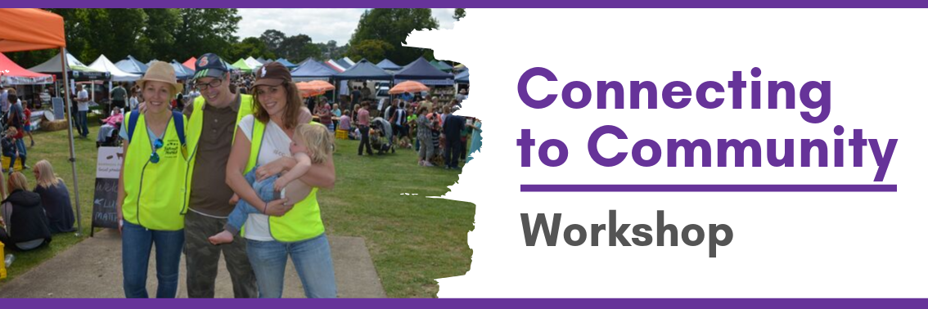

What this workshop is about
There still exists considerable concern that although people with a disability are physically present in our communities, they’re still disconnected and living lonely lives of isolation and segregation (Shut Out Report, 2009). Although we may hold the goal for more inclusive lives for people with a disability, we’re often unsure how to go about it! This workshop is a learning event for those who are serious about exploring and discovering opportunities for welcome, contribution and connection that are abound within our communities for people with a disability. This is a practical workshop. We will share stories and use interactive exercises, refection and discussion!

What we will discuss in this workshop

- Belonging and social inclusion—What is it and why is it important?
- Possible dis-connectors and connectors!
- Building a context for a full, meaningful and inclusive life,
- Discovering and harnessing potential, gifts, interests and passions,
- Typical pathways, harnessing roles and making the most out of community,
- Practical strategies that enhance, enable and strengthen belonging, connection and relationships,
- The role of the “supporter”,
- Facing struggles and challenges with creativity, and
- Sharing stories.

Who is this workshop for?
This free workshop will be of interest to family members and allies interested in assisting people with an intellectual disability to live full meaningful and inclusive lives in their communities. The material is also applicable to others who might experience marginalisation.

Facilitators
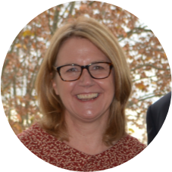
Deb Rouget is the CEO of Belonging Matters. For nearly 30 years, she has been involved in the lives of people with a disability and their families and has gained much practical experience and wisdom about imagining and designing supports that enable people with intellectual disability to live full, meaningful and inclusive lives in the community.
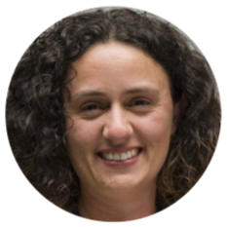
Teresa Micallef has worked alongside people with disabilities and their families for over 20 years. For 9 years she was the Coordinator of a family governed service called Living Distinctive Lives. Through this experience, Teresa has much to share when it comes to imagining and creating supports which foster inclusion and belonging.
We will also be joined by local story tellers who will share their story!

Workshop Event Details: It’s free but please register!
Date: Wednesday 20th November 2019 Time: 9.30am – 4.00pm (Lunch provided)
Venue: Mâché, 451 Pulteney St, Adelaide SA 5000
To register please visit: https://www.eventbrite.com.au/e/connecting-to-community-workshop-tickets-74915788139 or phone: Jackie (Purple Orange) on 8373 8331

Feedback from previous participants
Re-energizing. The interactive activities were great. Looking deeper into community and gaining a different perspective of the meaning of inclusion. Practical. Hearing about how to build connections. Fun. Captivating. Eye opening - deeply questioning in simple comfortable ways. Taking a new look at forming more social and local connections. Personal stories of contentedness - how it's us who has to step out of the dark! Tools to help me critically think how I support [my daughter] in community.

