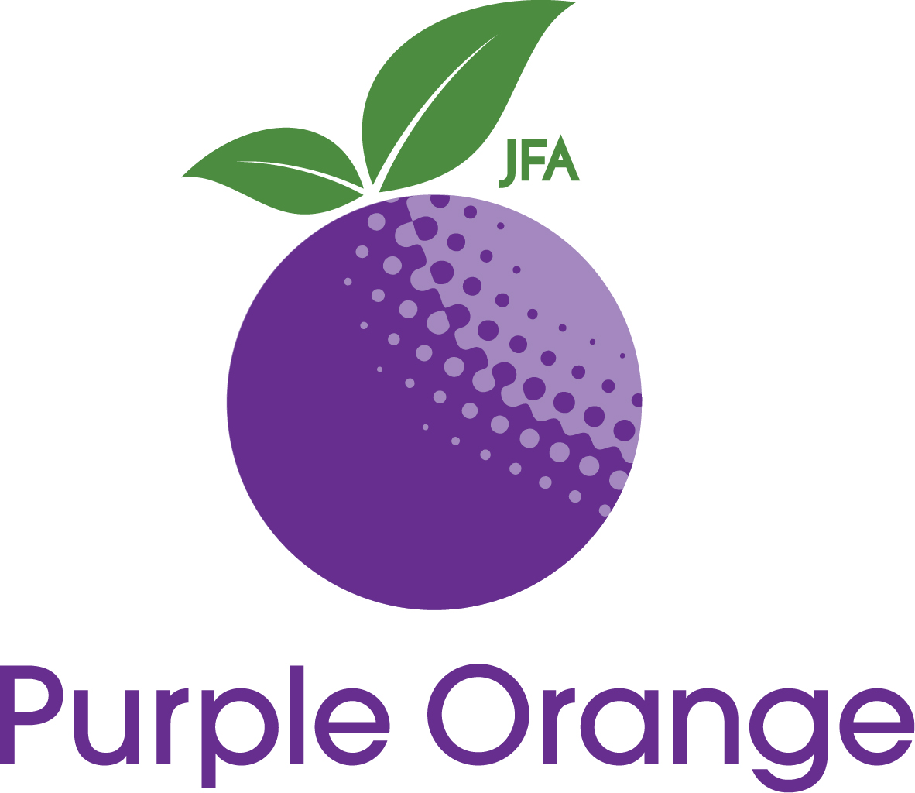

The survival of people-with disability organisations
Why it is important to sustainably fund diverse peak advocacy organisations in Australia

Robbi Williams, JFA Purple Orange

Publisher
JFA Purple Orange
104 Greenhill Road
Unley SA 5061
AUSTRALIA

Telephone: + 61 (8) 8373 8333
Fax: + 61 (8) 8373 8373
Email: admin@purpleorange.org.au
Website: www.purpleorange.org.au
Facebook: www.facebook.com/jfapurpleorange 1 (8) 8373 8333

Author
Robbi Williams
Robbi Williams MA BA (Hons) is an organisational psychologist with over 25 years international experience working in health and social policy and service systems. He has worked extensively in disability and mental health, covering a range of roles in policy, commissioning, service provision, deinstitutionalisation, community development, research and advocacy.

Robbi is CEO of JFA Purple Orange, an Adelaide-based community agency working in policy research, capacity-building and systemic advocacy.

Website: www.purpleorange.org.au

Copyright
This publication is copyright. Apart from any fair dealing for the purpose of private study, research, criticism or review, as permitted under the Copyright Act, no part of this publication may be reproduced by any process without written permission.

Requests for re-prints should be directed to JFA Purple Orange, PO Box 701, Unley Business Centre South Australia 5061 Australia. admin@purpleorange.org.au Face

© April 2016 Julia Farr Association Inc.

ISBN: 978-0-9925883-1-1

The survival of people-with-disability organisations
Why it is important to sustainably fund diverse peak advocacy organisations in Australia

Contents

1.0 Summary 3
2.0 Terms used 3 3.0 Introduction: the imperative 4 4.0 About diversity of voice and the UN Convention on the Rights of Persons with Disabilities 4
4.1.1 The importance of representative organisations 5
4.1.2 Safeguarding 5
4.1.3 Other elements of the UN Convention 5 5.0 The issue 6 6.0 The case for funding these agencies 6
6.1 The development of network 7
6.2 Volume of network 8
6.3 Representation of voice 8
6.4 Channels for information and consultation 9
6.5 Specialist knowledge 10
6.6 The importance of an independent voice 11 6.7 Importance of coherence 12 6.8 The importance of peer support 13
7.0 Concluding remarks 13

The survival of people-with-disability organisations
Why it is important to sustainably fund diverse peak advocacy organisations in Australia

Robbi Williams
CEO, JFA Purple Orange
Adelaide, April 2016

- Summary
At its heart, this paper argues the Australian government should ensure there is adequate investment in a broad range of national advocacy peak bodies, termed people-with-disability organisations, each working on behalf of a specific disability demographic (and/or the process for how a diversity of people living with disability are assisted to give voice to their aspirations and concerns). Between and within, these agencies bring credible value based on their histories, their networks, their information conduits, their specialist knowledge, and the voice of people living with disability, their families and advocates, within their governance.

Currently a number of these national agencies have been de-funded by government, which means they no longer have core funding to undertake their work. As a result, these agencies are at imminent risk of dissolving. The paper identifies a range of strengths and benefits these organisations bring. As such, it would be catastrophic if this capacity were lost through funding cuts. This is because the collective and individual contribution of these agencies and their representative networks is critical to the successful implementation of the National Disability Strategy, National Disability Insurance Scheme, and the honouring of Australia's commitments to the United Nations Convention on the Rights of Persons with Disabilities.

This paper is a companion to the opinion piece written by the author published January 2015.

- Terms used
This paper focuses on those agencies working at a national level on behalf of specific demographics within the disability community, for example people who are blind, people living with intellectual disability, et cetera. These agencies are not service providers, instead working in the area of representation and information, assisting their members to connect with information and each other on matters of common concern, and making representation on behalf of their members on national policy and practice matters.

This paper uses the collective term ‘people-with-disability organisations’ because that is the term being used by the agencies to describe themselves collectively.

Its use refers to agencies who work to a specific demographic (such as Brain Injury Australia, and Physical Disability Australia), and agencies who are centrally involved with the methodology of advocacy and consumer voice (such as DANA and AFDO).

- Introduction: the imperative
The National Disability Strategy (NDS) and the National Disability Insurance Scheme (NDIS) signal the possibility of a new era where people living with disability and their families have a fair go at taking up ordinary valued roles in community life and the economy, and characterised by choice and control.

However, given the size of the social welfare reform, and the number of actors involved in the development of policy and practice that guide implementation, it is important people living with disability and their families are present and potent in such deliberations.

Put simply, if the NDS and NDIS are authentic about the goal of advancing choice and control by people living with disability, this needs to be evident every step of the way.

It is also important this happen in a way that reflects the diversity within the disability community.

- About diversity of voice and the UN Convention on the Rights of Persons with Disabilities
Like many agencies and communities, governments typically use collective terms to people living with disability. This can include terms as ‘persons with disabilities’, ‘people with disabilities’, ‘people living with disability’, and the like. A collective term is obviously helpful and important because it helps identify a broad demography of people who are the intended beneficiaries.

However, the problem with such terminology is that it can inadvertently create the impression that the disability community is homogenised; that its members are people with similar issues and similar outlooks. This is not so. The advent of the NDS and NDIS will mean different things for different people, depending on their demographic circumstances. The specific issues that stand in the way of a person who is blind getting a fair go will be different, at least in part, to the issues for a person living with autism and different again for a person who lives with quadriplegia.

This means not only must there be adequate investment in the voice of people living with disability and their families, but also that such investment happens in ways that properly acknowledge the diversity of the disability community.

Importantly, even though the UN Convention uses a collective phrase (‘persons with disabilities’), the Convention carries specific signals relating to diversity. For example, in Article 3d the Convention acknowledges respect for difference and diversity. Intuitively, this includes the diversity within the disability community.

    - The importance of representative organisations
Article 4.3 says the State Parties (this includes Australia) shall consult with and actively involve persons with disabilities, including children with disabilities, through their representative organisations.

In Australia, some of those representative organisations are currently under imminent threat of closing down because they are not in receipt of sustainable funding. It will be difficult for Australia to honour this component of the UN Convention if its government is not making sufficient investment in the agencies people choose as their representative organisations.

I emphasise here they are agencies that people choose. Typically, these people-with-disability organisations have significant memberships of people with relevant lived experience. In other words, people living with disability have selected, through the act of subscription and membership, a specific national peak advocacy agency (either directly, or indirectly through membership of a local counterpart agency) to represent their views nationally.

It would therefore be an odd thing for a State Party to the UN Convention not to invest in national, advocacy peak agencies that carry a significant representative mandate given by their members, including those peak agencies that are authentically consumer led.

    - Safeguarding
Also, given the independence these agencies have (they do not have other roles that may present conflict of interest, for example through being service providers), they play a critical monitoring role in how people living with different types of disability are assisted by facilities and programs. The presence of these agencies can help prevent or resolve the occurrence of exploitation, violence or abuse. This is as per Article 16 of the UN Convention.

This is not to say that such agencies are the only system safeguard against exploitation, violence or abuse. However, based on the author’s experiences elsewhere, system safeguards have more chance of being effective if there are multiple channels where concerns can be identified and raised. The absence of these agencies in their activities implies a reduction in the range of safeguarding channels available, and that is not good.

    - Other elements of the UN Convention
These people-with-disability organisations have specialist knowledge and networks within specific disability demographics. This means they can play a critical role in assisting Australia to meet its UN Convention obligations in relation to Article 5 on quality and non-discrimination, Article 8 on awareness raising, and Article 9 on accessibility. This can also extend to Article 10 on right to life, Article 12 on equal recognition before the law, Article 13 on access to justice, and Article 17 on protecting the integrity of the person. The list continues, including Article 19 on living independently and being included in the community, Article 20 on personal mobility, Article 21 on freedom of expression and opinion, and access to information, and so on.

In fact, it is hard to imagine the successful delivery of each of the Convention’s articles without a State Party accessing the expertise and representative networks of specific disability demographics as reflected for example in national people-with-disability organisations and their local counterparts.

- The issue
The previous section suggests there may be a compelling rights-based scenario for carefully investing in people-with-disability organisations. Currently, there are people-with-disability organisations operating nationally that do not have sustainable funding.

Almost all of these agencies did have Australian government funding but lost it in a December 2014 decision by the Commonwealth Government's Department of Social Services. That decision heralded an overall reduction in funding to national people-with-disability organisations, redirecting some of these funds to several other agencies who were successful in a tendering process.

This paper in no way suggests those other agencies should have such funding removed. Such agencies have history with specific sections of the disability community and deserve funding recognition for the same reasons set out in this paper.

Instead, there are national people-with-disability organisations with a specialist history of representation on behalf of specific disability demographics that are at imminent risk of closing down because of government cuts to their core funding. This paper argues that their disappearance will be profoundly counter-productive to the successful implementation of the NDS and NDIS, and will constitute the loss of consumer networks that have taken years to develop.

- The case for funding these agencies
The author has considered a range of summary information provided to the author in mid-April by the agencies in question. The agencies who have supplied information are, alphabetically:

- Autism Aspergers Advocacy Australia (A4)
- Australian Federation of Disability Organisations (AFDO)
- Australian DeafBlind Council (ADBC)
- Blind Citizens Australia
- Brain Injury Australia
- Deaf Australia Inc
- Deafness Forum of Australia
- Disability Advocacy Network Australia (DANA)
- Down Syndrome Australia
- Inclusion Australia
- Physical Disability Australia.

This has been supplemented by the author’s own experiences of the role of these types of agencies in human service systems in Australia and overseas. Initial analysis suggests there are a number of key common benefits that emerge from the work of these types of agencies.
  - The development of network
First, these agencies have networks of members, typically comprising people living with a specific type of disability, their families and supporters. Building such networks takes time, because momentum is driven by each person's choice. If a person cannot see the benefits of a network, they are unlikely to join it or stay in it.

For example, Blind Citizens Australia has developed a network of over 3000 people who are blind or have low vision. One might easily imagine that typically each of these people have taken up membership of that network because they are confident that national peak advocacy agency can bring benefits, including being a representative voice on national issues that may affect people who are blind or live with vision-impairment.

Such networks do not happen overnight, because of what is involved in developing connections and relationships. Sustainable community development is a marathon, not a sprint. In the author's experience, and with few exceptions, it takes years not months to develop and consolidate sustainable active networks of members.

In the case of Blind Citizens Australia, they have operated for more than 40 years and whose current network will have been built over that time.

There will be comparable stories of history and network in the other agencies mentioned above, ranging from A4’s 13 years of network activity to Inclusion Australia’s 62 years.

Such networks are dynamic not static. This means that each agency has to have regular active contact with its network to help maintain its currency and benefits. Without such investment, networks can lose momentum.

This is evidenced in South Australia, where several local demographic-specific networks have been compromised by withdrawal of resources.

Once lost, such active networks cannot easily be recreated through different channels, precisely because they are the product of time and relationship, characterised by growth of trust and confidence.

It is important to emphasise here that because each member makes an active choice to join a network, and stays with it due to trust and confidence, it is unwise to assume that such networks can be reassigned via a tender process. Typically, people choose the networks that they wish to represent their views, rather than have them allocated by a disinterested third party.

As such, instead of a competitive tendering process, the resolution of funding for such representative networks is better approached on the basis of a negotiated grant linked to key indicators about the maintenance, growth and outputs of such networks.

  - Volume of network
The defunded agencies mentioned earlier in this paper have coalesced as Disability Australia, along with many similar agencies. Including Blind Citizen Australia's statistic of 3000 network members, that group cites a combined membership of over 200,000 members across 140 organisations. The group identity itself has over 27,000 followers in social media.

These data speak to a substantial collective network of people living with various types of disability, to which each national peak advocacy agency makes its own unique contribution. Again, given the policy and practice imperatives that need to be addressed in the implementation of the NDS and the NDIS, it makes sense to find ways to invest in the maintenance and growth of such networks, because of the numbers of people involved therein. They are a substantial audience who potentially can be reached to assist Australia’s governments resolve well-considered social policy and practice.

  - Representation of voice
Through each person's choice to join the network of a national peak advocacy agency, such agencies carry a mandated representative role. Importantly, because of the specific demography of its members, these types of national peak advocacy agency bring a highly specialised perspective that cannot easily be replicated through generalist disability channels. As mentioned earlier, this is because people choose their representative networks. Such choices are likely to be highly influenced by the extent a person can trust an agency to bring empathy, experience and insight specific to that person’s own experiences.

There is a diverse range of people who will be participants in the NDIS, and the Scheme needs to grow its effectiveness based on their feedback and insights. Mindful there needs to be a robust mechanism for individual participants to give individual feedback without fear of penalty, it seems imperative there is also a sufficient diversity of representative networks. This is so NDIS participants and their families can choose the channel they feel works best for what they want to say.

This is not just about individual advocacy but also about how to make sure people's views are known collectively, through networks of ‘people like me’. A shared collective voice about a specific set of disabling circumstances seems critical if there is to be a high-functioning NDIS that can deliver genuine personalised responses to a wide diversity of situations.

For example, Brain Injury Australia responds to numerous requests and has an outreach (utilising data obtained by Brain Injury Australia from the Department of Social Services on all people with an ABI as their "grant reason" for a Disability Support Pension, disaggregated by Local Government Area) with broad public education campaigns built around under-acknowledged groups of people with an ABI.

Important though the NDIS is, the representative work these agencies undertake goes far beyond the mechanics of the disability support funding mechanism. It goes to the National Disability Strategy and the rights and aspirations that underpin it. These agencies have variously contributed to key conversations and developments in relation to building accessibility, mainstream employment, inclusive education, accessible communications, and a range of other matters that impact on society, through to the articulation of disability rights nationally and internationally.
As such, it would be unsafe to assume the debate about their funding should wholly play out in the NDIS’s ILC framework which is designed to fund work relating to information, linkages and capacity building. Apart from an unsympathetic timeframe – the ILC framework is unlikely to be operational in a timeframe that can support the survival of these people-with-disability organisations – these agencies operate at a much broader level, and sustainable funding might best come from a government source that reflects that.

  - Channels for information and consultation
Because of their connections to their members, people-with-disability organisations can be effective channels for information. This can help ensure that information from Government and other mainstream services can reach specific disability demographics in ways that maximise accessibility for that particular group.

Given the history of activity of agencies like those referenced in this report, they can be a particularly compelling channel for information because the channel is trusted. This is not to say that other channels are routinely mistrusted. Instead, because of the nature of these types of organisations, who come from a place of empathy, of shared experience, and without other potentially conflicting vested interests, the information they provide is often more trusted because it is seen as coming from an independent yet empathetic source.

I am inclined to agree with the view that information is of most help to people living with disability and their families when it:

- Comes from a trusted source
- Does not have an ulterior marketing purpose
- Upholds the person’s role as a decision-maker
- Supports the person to take action
- Genuinely informs choices, resulting in better individual decisions
- Contributes to a safeguarding mechanism because of the above

Given the information-driven world we now live in, the sheer volume of information available can easily overwhelm people. It can be hard for anyone, regardless of his or her personal circumstances, to tease out which information is relevant, useful and reliable. This becomes a critical issue for people who live with greater vulnerability.

The work of people-with-disability organisations includes information services and networks that can help people living with disability access information that is genuinely helpful, to reduce the risk of the person being ripped-off and to increase the chances of the person making a well-informed decision about their choices.

Critical to this is accessibility. These agencies bring specialist knowledge in how to best render information in the format people need (for example Auslan, Braille, Easy English, captions, audio transcription, and so on) and via the interface they prefer (e.g. online, mobile, in print, free-to-air media, face-to-face opportunities in appropriate settings, and so on). This is vital for people with disability so that they can access information directly and not via third parties carrying vested interests.

Without the involvement of such agencies, these communications are at risk of being less effective. Feasibly, this can lead to adverse consequences in a ‘negative value chain’ where suboptimal communications lead to suboptimal stakeholder understanding which in turn leads to suboptimal decision-making which in turn leads to suboptimal actions and therefore suboptimal or even adverse consequences.

Given what is at stake with the rollout of the NDS and the NDIS – suboptimal is not acceptable – this seems a prima facie case for investing in the continuation of the work of national people-with-disability organisations and their local counterparts to preserve this important information pathway.

This is important not just to push information out to the members of these networks, but also to seek the views and experiences of those members. As mentioned earlier in relation to the volume of network these agencies represent, the Australian Government has the opportunity to consult a very large number of people. This can assist the development on a range of public policy and practice issues that might affect the life chances of Australians living with disability and their families, and more broadly on the prospects for Australian society and economy.

  - Specialist knowledge
Similarly, because each agency is immersed in the experiences and issues specific to a particular disability demographic, these agencies have been important sources of specialist knowledge and insights into the aspirations and concerns of particular demographics within the disability community.

If such agencies are no longer viable, this accumulated knowledge capital is lost, and can take years to regenerate. Some of the agencies concerned have developed high levels of specialist expertise in areas critical to society and economy. For example, Inclusion Australia can be regarded as a genuine national authority on the matter of mainstream waged employment for people living with intellectual disability. They have achieved that reputation not just because of the specific research they have undertaken in the area but also because of what they are able to learn through their core networking business as a national peak advocacy agency with a large membership of people living with intellectual disability, their families and supporters.

The author refers to his own agency to illustrate the importance of Inclusion Australia’s role. JFA Purple Orange seeks a range of ways to advance the life chances of people living with disability and their families. Among other things, the agency’s work includes research, policy development and systemic advocacy. The agency has a significant network of stakeholders whose views contribute to this.

However, the agency, which considers itself a generalist in the disability field, would not presume to be able to replace specific demographic networks with its own. That is the job of demography specific agencies because they can place their entire focus on the perspective of a particular section of the disability community. After all, that is what it takes to build a deeper insight into specific experiences.

The quality of JFA Purple Orange’s own work continues to rely on the endeavours and networks of national people-with-disability organisations and their local counterparts, so that it can build a comprehensive understanding of issues across the disability community. In terms of mainstream waged employment and other matters affecting Australians living with intellectual disability, JFA Purple Orange relies heavily on the expertise and experience of Inclusion Australia, and their closure would represent a substantial loss of knowledge capital in the sector.

Again referencing the local situation in South Australia where the author is based, there are examples of demographic-specific consumer organisations losing financial sustainability and their work subsequently being incorporated into other more generic agencies. Members of those networks report a subsequent dilution of specialist insights and, more worryingly, a loss of identity, fellowship and voice. Given the challenges that lie ahead in the implementation of the NDS and the NDIS, and given the key values professed in those endeavours, it seems unwise to deny essential funding for diverse representative networks.

Referring back to the national level, the National Disability Insurance Agency currently runs a regular forum to engage key stakeholder agencies on matters relating to the NDIS operational design and implementation. The forum has a key place in the consultation and co-design processes the NDIA has said are important.

Almost all of the people-with-disability organisations referenced in this paper are members of that forum. If those agencies close down, the forum will lose a substantial part of its membership. One can reasonably assume this would have an adverse effect on the product of consultation and co-design.

  - The importance of an independent voice
A significant number of disability agencies have an identity specific to a particular section of the disability community (e.g. Down Syndrome, Parkinson’s, etc). Typically, such agencies emerge because of the shared aspirations and concerns of people living with similar issues. Early in the life of such agencies, activities tend to be focused on information, capacity building, linkages and representation of voice.

Unfortunately, with the advent of a ‘contracts culture’ in government purchasing of disability services over the past 20 to 30 years, evident in a number of developed economies including Australia, these activities typically do not attract significant funding because governments focus on what they see as the essential disability supports. As a result, some of these disability-specific agencies adapt in order to survive, by changing their work profiles to provide therapy, respite, etc so they can bid for funding. In so doing, they morph into service providers, at least in part.
This compromises the independence of the agency. It is difficult to speak up on behalf of a membership when the target for advocacy – often Government – is also the agency's main customer.

The specific agencies referenced in this paper, along with at least some of their local counterparts, have strived to avoid this so they can offer a truly independent perspective on behalf of their members and networks.

The arrival of the NDIS means there is potential to move away from a contracts culture. This is because the purchasing decision shifts to the individual consumer. With the UN Convention and NDS as context, this funding reboot heralds a precious opportunity for the Australian Government to invest properly in the sustainability of such agencies. This can assure a diversity of independent perspectives contributing to the implementation of the NDS and NDIS and, more broadly, the creation of a truly inclusive and diverse Australia.

  - Importance of coherence
In its 2014 funding decisions on matters of national peak advocacy, the Australian Government clearly signalled the importance of connecting with diverse experiences within the disability community. This is because its commissioning work at that time recognised and prioritised the demographics of children living with disability, women living with disability, Aboriginal people and Torres Strait Islanders living with disability, and people living with disability who are from culturally and linguistically diverse backgrounds.

Each of these represents a specific section of a diverse disability community. However, if such commissioning priorities were intended to ensure that specific sections of the disability community have a specialist channel for their voice to be heard, then the commissioning did not go far enough.
The 2014 commissioning decisions signal there is a qualitative difference between the circumstances of women living with disability, as compared to female children living with disability, as compared to Aboriginal and Torres Strait Islander women living with disability, and as compared to women living with disability who are from culturally and linguistically diverse backgrounds. If so, then one must assume there is a similar imperative to respond to other types of diversity such as networks that can respond to women who are blind, women who are deaf, women who live with intellectual disability, women who live with physical disability, and so on.

Therefore, if the Australian Government wishes truly to recognise and invest in a diversity of voices within the disability community, this needs to be accomplished through a more complete approach. Instead of investing in a small handful of prioritised demographics, the Australian Government could invest systematically in the development and sustainability of a broader range of specialised networks and channels that properly reflect the diversity of the disability community.

  - The importance of peer support
In addition to the other benefits these agencies bring to the disability system, they also constitute a peer support mechanism. Communities-of-interest and communities-of-practice are likely to play an increasingly important role in helping to unlock the hoped-for benefits of social welfare reform.
Indeed, an important contribution of agencies like DANA and AFDO is to facilitate a peer support mechanism, so that each of the participating member agencies can evolve their capacity and impact through shared learning.

This in turn can cascade to state/territory counterparts and on to local networks, and ultimately to the thoughts and actions of the members of those networks - individual people living with disability, their families and supporters.

If these agencies are not able to access sustainable funding, that peer support mechanism is lost. This means there is lost opportunity for people to share information and ideas, and thereby there is lost opportunity for the evolution of practice, not just at the level of national people-with-disability organisations, but also in their local counterparts and individual network members.

As such, the loss of these agencies can bring adverse consequences in terms of the pace and character of how people living with disability are equipped as NDIS participants and more broadly as included citizens.

This is not to say the entire future of people’s capacity and inclusion rests with the fate of the national people-with-disability organisations; there is of course a range of factors that need to be considered. However, given the complexity of this social welfare reform, there is a self-evident need for a collaborative approach across all areas. The national people-with-disability organisations are part of that collaboration. It does not make sense to divest and remove their involvement, particularly given their work to support the consumer voice.

- Concluding remarks
The author has written this paper to assist disability stakeholders, including the Australian Government, consider how best to invest in the collective voice of the Australian disability community. The matter is urgent because a number of national people-with-disability organisations have been the subject of government funding cuts, and are in imminent danger of closing down.

The paper has attempted to offer a brief analysis of the strengths and experiences of national people-with-disability organisations and their local counterparts. It is hoped this has helped illustrate the magnitude of loss if these agencies close down.

Systematic investment in a diversity of national networks within the disability community can assist Australia to meet its commitments within the United Nations Convention on the Rights of Persons with Disabilities.

This investment can also help ensure that Australia does not lose the significant knowledge capital and social capital that such member networks represent.

Importantly, such investment can assist the prospects of a successful and coherent implementation of the National Disability Insurance Scheme and the National Disability Strategy. Therefore, truly sustainable funding for these agencies might best come from a government source outside the NDIS, and must be resolved quickly.

The split infinitive is intentional, to emphasise a qualitative difference between ‘funding’ and ‘sustainable funding’
http://probonoaustralia.com.au/news/2015/01/the-voice-of-the-disability-community-stifled-in-one-fellswoop/ available online as at 18 April 2016
From conversation with Matt Wright, AFDO, April 2016

