Job description

JFA Purple Orange

Team Member

**About Purple Orange**

JFA Purple Orange is an independent South Australian organisation.

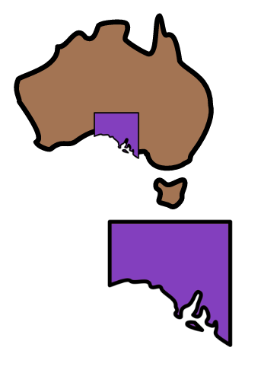

The work JFA Purple Orange does helps people who live with disability get a fair go.

**About the Job**



This job is for a person who lives with disability.

You will work as a **Facilitator** with our project staff.

A facilitator is the job name for someone that works on our project.

You will work on 2 projects

* Disability Inclusion Training

and

* SKILL



This is a casual job.

That means you will work different hours and different days.



Some weeks you might have no work.



The job will be for 6 months.

Things you will do in the job



* You will work with another facilitator in Mount Gambier.

or



* With another facilitator in the country.

Help run workshops about things like

* disability
* A picture containing shape

  Description automatically generatedhuman rights
* barriers
* language
* communication
* employment
* School

Things you need to do or have



**Good presentation skills**

* Speak clearly.
* Share stories.



**Good organisation skills**

* Follow instructions.
* Ask questions.

**Confident and friendly person**

* Work well with other people.
* Be respectful to others.

**Access to reliable transport**

* Be able to arrive at workshops on time.

**NDIS Clearance**

* Get a NDIS Clearance,

This is a check to make sure you are safe to work with people with disability.

How to apply for this job

1. Answer the questions on the application form.

You can have someone help you fill in the form.

1. Send the form to us.



104 Greenhill Road

Unley SA 5061



[inclusiontraining@purpleorange.org.au](mailto:inclusiontraining@purpleorange.org.au)

If you need help or have any questions, please contact Tara.



Tara



8373 8388.



[inclusiontraining@purpleorange.org.au](mailto:inclusiontraining@purpleorange.org.au)